fscBOX API File Download Step

Objective

Retrieves the actual data of the file. An optional version parameter can be set to download the previous version of the file.

UI

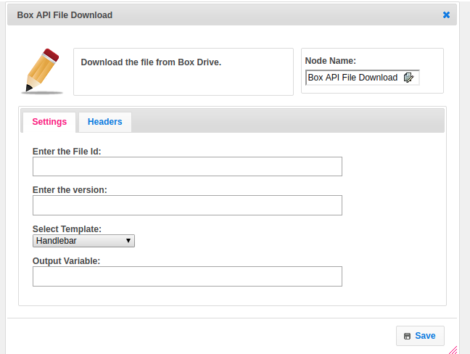

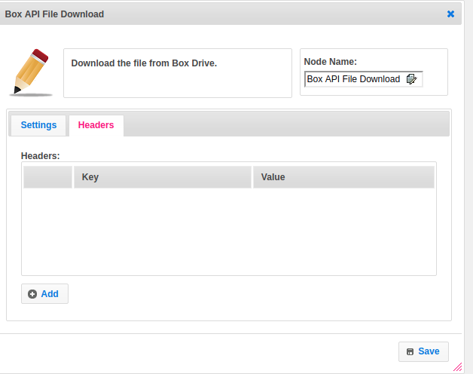

## Attributes

|  |  |
| --- | --- |
| **Attributes** | **Description** |
| **1. Enter the file Id** | File id contains the unique id of the file given by Box user account. |
| **2. Enter the version** | Optional file version ID to download (defaults to the current version) |
| **3. Select Template** | The template used to set the value type.  Value types are two types.  1.hb-HandleBars  2.ftl-Freemarker Template Language. |
| **4. Output Variable** | Used to store the response of the request. |
| **5. Headers** | In header list, The mandatory values like Authorization credentials, by setting key as Authorization value as Bearer accessToken and optionally pass Range**,** the [range](http://www.w3.org/Protocols/rfc2616/rfc2616-sec14.html#sec14.35) value in bytes. Ex:Format should be bytes={start_range}-{end_range} |

## Executor Description

If the file is available to be downloaded, the response will be a 302 Found to a URL at dl.boxcloud.com. The dl.boxcloud.com URL is not persistent. Clients will need to follow the redirect in order to actually download the file. The raw data of the file is returned unless the file ID is invalid or the user does not have access to it.

If the file is not ready to be downloaded (i.e. in the case where the file was uploaded immediately before the download request), a response with an HTTP status of 202 Accepted will be returned with a Retry-After header indicating the time in seconds after which the file will be available for the client to download.

## Dependent Plugins

|  |  |
| --- | --- |
| **Attributes** | **Description** |
| Key | Key is nothing but **Client ID**.  The client id is a public identifier for apps. Even though it’s public, it’s best that it isn’t guessable by third parties, so many implementations use something like a 32-character hex string. It must also be unique across all clients that the authorization server handles. If the client ID is guessable, it makes it slightly easier to craft phishing attacks against arbitrary applications. |
| Secret | A secret is nothing but the **Client Secret.**  The client secret is a secret known only to the application and the authorization server. It must be sufficiently random to not be guessable, which means you should avoid using common UUID libraries which often take into account the timestamp or MAC address of the server generating it. A great way to generate a secure secret is to use a cryptographically-secure library to generate a 256-bit value and converting it to hexadecimal representation. |

## Resource

More information about Box API file download please refer the following link.

<https://developer.box.com/reference#download-a-file>